**May 13, 2019**

**Subject: RFP No. 9442.2, Energy Management Systems Contractor’s Prequalification**

This is Amendment Number 1.

In accordance with the terms of the above-mentioned contract, the following companies remain pre-qualified to provide services through May 31, 2020. All terms and conditions remain the same.

**Suppliers: Building Automation Services, Inc.**

**Control Sources, LLC**

**Engineered Services, Inc.**

**Performance Controls, LLC**

**Pritchett Controls, Inc.**

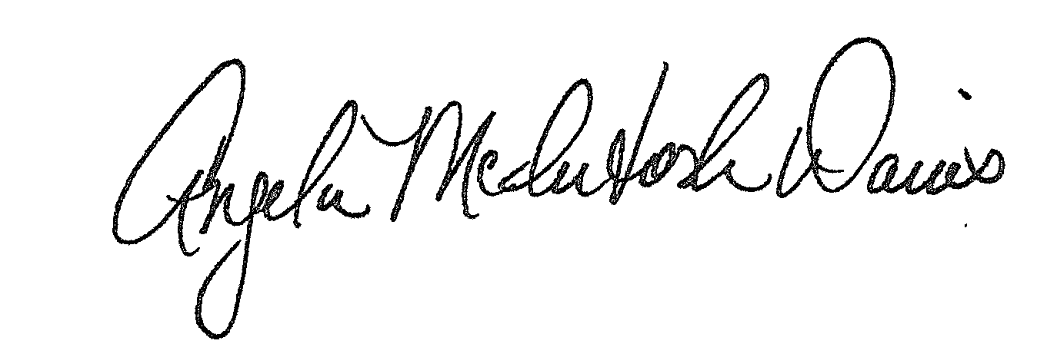**REFER QUESTIONS TO:** Laly Bowers, Buyer II, 301-279-3637

Approved:

Angela McIntosh-Davis, CPPB, Team Leader, Procurement Unit

AMD:lb

Distribution: Supplier(s); Bid File